## **Week 5 Homework Submission File: Archiving and Logging Data**

Please edit this file by adding the solution commands on the line below the prompt.

Save and submit the completed file for your homework submission.

### **Step 1: Create, Extract, Compress, and Manage tar Backup Archives**

1. Command to **extract** the TarDocs.tar archive to the current directory:

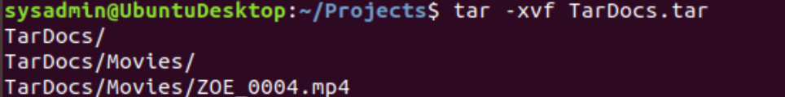

1. Command to **create** the Javaless_Doc.tar archive from the TarDocs/ directory, while excluding the TarDocs/Documents/Java directory:



1. Command to ensure Java/ is not in the new Javaless_Docs.tar archive:



**Bonus**

* Command to create an incremental archive called logs_backup_tar.gz with only changed files to snapshot.file for the /var/log directory:

#### 

#### **Critical Analysis Question**

* Why wouldn't you use the options -x and -c at the same with tar?

### **Step 2: Create, Manage, and Automate Cron Jobs**

1. Cron job for backing up the /var/log/auth.log file:



### **Step 3: Write Basic Bash Scripts**

1. Brace expansion command to create the four subdirectories:  
   

Paste your system.sh script edits below:  
  
 #!/bin/bash

1. [Your solution script contents here]

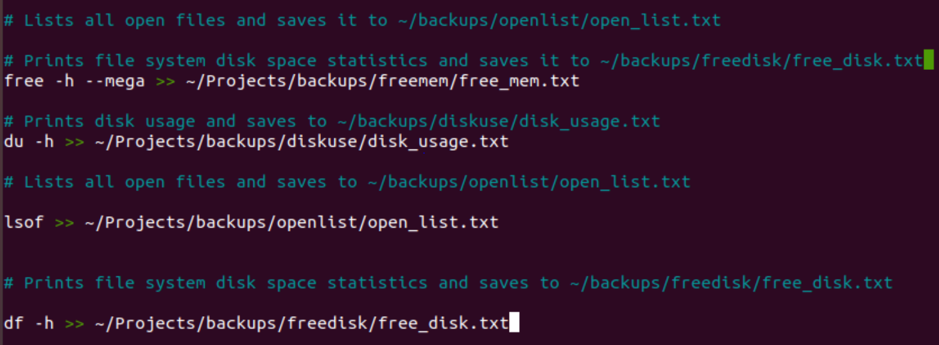

1. Command to make the system.sh script executable:



**Optional**

* Commands to test the script and confirm its execution:

**Bonus**

* Command to copy system to system-wide cron directory:

### **Step 4. Manage Log File Sizes**

1. Run sudo nano /etc/logrotate.conf to edit the logrotate configuration file.  
     
    Configure a log rotation scheme that backs up authentication messages to the /var/log/auth.log.  
   * Add your config file edits below:
   * Configure a log rotation scheme that backs up authentication messages to the /var/log/auth.log directory using the following settings:
     1. Rotates weekly.
     2. Rotates only the seven most recent logs.
     3. Does not rotate empty logs.
     4. Delays compression.
     5. Skips error messages for missing logs and continues to next log.  
         Don't forget to surround your rotation rules with curly braces {}.
2. 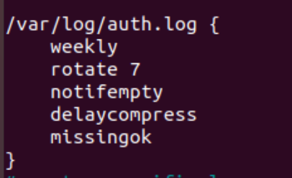

### **Bonus: Check for Policy and File Violations**

1. Command to verify auditd is active:
2. Command to set number of retained logs and maximum log file size:  
   * Add the edits made to the configuration file below:
3. [Your solution edits here]
4. Command using auditd to set rules for /etc/shadow, /etc/passwd and /var/log/auth.log:  
   * Add the edits made to the rules file below:
5. [Your solution edits here]
6. Command to restart auditd:
7. Command to list all auditd rules:
8. Command to produce an audit report:
9. Create a user with sudo useradd attacker and produce an audit report that lists account modifications:
10. Command to use auditd to watch /var/log/cron:
11. Command to verify auditd rules:

### **Bonus (Research Activity): Perform Various Log Filtering Techniques**

1. Command to return journalctl messages with priorities from emergency to error:
2. Command to check the disk usage of the system journal unit since the most recent boot:
3. Comand to remove all archived journal files except the most recent two:
4. Command to filter all log messages with priority levels between zero and two, and save output to /home/sysadmin/Priority_High.txt:
5. Command to automate the last command in a daily cronjob. Add the edits made to the crontab file below:  
     
    [Your solution cron edits here]

© 2020 Trilogy Education Services, a 2U, Inc. brand. All Rights Reserved.